From: https://davidstockmanscontracorner.com/now-comes-the-turbulent-twenties-the-gop-gone-awol-and-the-scourge-of-keynesian-central-banking-part-4/
Keywords: 16% trimmed-mean CPI,

Now Comes The Turbulent Twenties: The GOP Gone AWOL And The Scourge Of Keynesian Central Banking, Part 4
By David Stockman. Posted On Thursday, December 26th, 2019
Capitalist prosperity and constitutional governance are under dire existential threat in America, and the three main causes are the Fed, the Fed and the Fed.
And to the Fed's maleficent monetary malfeasance we can add the abject abandonment by the modern Republican Party of its duty to do battle for the cause of sound money and fiscal rectitude. Yet without those bulwarks, the dynamics of American democracy itself virtually guarantee that prosperity will be smothered by an ever expanding state and ever shrinking sphere of constitutional government and personal liberty.
Indeed, even as the Fed has gone about destroying the foundations of capitalist prosperity, the present day GOP has wandered deep into the wilderness of state aggrandizement by embracing the misbegotten projects of Imperial Washington. We are referring to the neocon-fostered pursuit of Empire abroad and the anti-liberty embrace domestically of culture wars, border wars, anti-immigrant nativism and now, under Trump, protectionist trade policy.
Notwithstanding the Donald's stated aim of draining the Swamp, the GOP's embrace of Keynesian central banking, imperial foreign policy, fiscal profligacy and statist nativism actually ensures just the opposite. None of these projects can be implemented without extending the state's fiscal, monetary and regulatory intrusions into what should be the province of free markets and a liberty-based social order.
So Leviathan threatens anew as the Turbulent Twenties commence. The leading edge of this onslaught is impending fiscal catastrophe, an era of inconstant and anemic economic growth, a rapidly metastasizing maldistribution of wealth and a egregiously inflated and unstable financial system that is heading for a spectacular implosion.
All four of these ills stem from the destructive regime of Keynesian central banking which has arisen, congealed and become institutionalized during the past 30 years.
Needless to say, in the great scheme of things, the GOP's historic job in American democracy was to fight this kind of deadly statist assault with hammer and tongs; it was supposed to be the guardian of fiscal rectitude, sound money, small, decentralized government and the free market engine of capitalist prosperity.
So the question recurs. Why did the Republican Party go utterly, deeply and irretrievably AWOL on its fundamental mission?
There can be no doubt about the real answer. First and foremost, the so-called conservative party has been coopted by the cult of central banking which reigns supreme on both ends of the Acela Corridor.
As we shall demonstrate, once the state is in the aggressive business of issuing bad money and falsifying the entire range of financial asset prices----from overnight money to benchmark treasury notes, junk bonds, equities and anything else which is traded in the casino---all the other aforementioned ills inexorable follow.
In this context, for example, it is not surprising that the moneyed classes want Easy Money because it drastically and artificially inflates their financial assets.
Likewise, the Beltway political class embraces Easy Money because it deflates the carry cost of the nation's mushrooming debts; and the massive vested interests which feed on the Warfare State/Welfare State behemoth---that is, the beneficiaries of Empire and Entitlements---could not survive, let alone thrive, without a red hot printing press at the ready in the Eccles Building.
So the GOP---and especially its so-called conservative wing---has parked its economic principles in what amounts to an ideological safe deposit box, pretending to be oblivious to the Fed's assault on everything it purportedly holds dear.
A measure of how far the establishment Republicans of the Imperial City have strayed from their bedrock economic principles was evident in the response to one the Donald's latest whacky tweets about the Fed.
That is to say, in the passage below the Donald was propounding downright monetary crankery, but there was nary a peep from the GOP peanut gallery on Capitol Hill. And that wasn't because they were being polite or discreet.
The fact, is most of the GOP cowboys on Capitol Hill voting for massive defense budgets, gargantuan fiscal deficits and bloody-minded foreign interventions across the fairest parts of the planet no longer have a clue about what sound money really is, and why all else depends upon it.
So an ostensibly a Republican president meet with the Federal Reserve Chairman to advocate sheer monetary heresy---negative interest rates, more easing and trashing the currency---and no one blew the whistle.
Just finished a very good & cordial meeting at the White House with Jay Powell of the Federal Reserve. Everything was discussed including interest rates, negative interest, low inflation, easing, Dollar strength & its effect on manufacturing, trade with China, E.U. & others, etc.
Regardless of how Powell bobbed and weaved in the face of this blithering POTUS nonsense, the mere fact that such monetary crackpottery was discussed in the White House (East Wing residence, at that!) tells you all you need to know about today's financial madness.
To wit, not only have decades of Keynesian central banking blatantly falsified the prices of financial assets--- it has also deeply falsified and corrupted the financial narrative itself. The very propositions implicit in the Donald's tweet that we need easier money because inflation is too low, the dollar's too strong and there's negative interest rates abroad are demonstrably ludicrous.
Yet they are considered valid by most of Washington, virtually all of the GOP and much of Wall Street---and at least debatable by even mainstream skeptics who think the Donald over-states the matter.
In truth, however, the starting point and lynch-pin for the proper functioning of the entire financial market is the relationship between inflation and the money market rate of interest. In any rational, stable and sustainable financial system the spread of money cost over inflation must always be positive, and vary higher or lower over time based on the supply and demand for funds.
Yet the what the Fed holds to be the central money market indicator---the Fed funds rate--- crossed under the running inflation rate way back in March 2008 when it stood at 2.60% versus the CPI, which posted at 2.95% on a year-over-year basis.
At that point, the inflation-adjust or "real" money market rate computed to negative 35 basis points, and remained in negative territory--sometimes by 200 basis points or more---for the next 130 months running until late 2018.
There is no precedent for anything like this in all of financial history--even during the Great Depression, as shown below. That's because negative real interest rates on a sustained basis are completely impossible on the free market where use of money has an inherent time value.
So what has been foisted upon the US financial system ever since the 2008 crisis is extreme central bank financial repression of a virulence that wasn't even imaginable before then.
Stated differently, the last decade has been an assault on financial law itself----to say nothing of the savers and fixed income retirees who have been financially brutalized and expropriated by this toxic regime of negative cost money.
As it happened, it wasn't until January 2019 that a positive real money market spread peeked out from the shadows of the Fed's long night of financial repression. At that point, the money market benchmark rate (Fed funds) returned to 2.40%, thereby reflecting the grand sum of 21 basis points of positive real yield compared to the running inflation rate of 2.19%.
Needless to say, under the combined onslaught of the crybabies and entitled gamblers of Wall Street and the financially ignorant bully in the Oval Office, that interval of positive money market spreads lasted just seven months.
Thereafter, as is evident in the chart, the spread turned negative again by 11 basis points in August after the Fed's rate cut capitulation at its July meeting. It's been off to the races ever since.
Today, the Fed funds rate stands at 1.55% versus a November year-over-year inflation reading of 2.35%.
That's right. We are back to negative 80 basis points on the real cost of money, yet we have a Republican party---taking its lead from the Oval Office---which wants the Fed to drive the spread even deeper into negative territory, thereby further defying every traditional canon of sound money---to say nothing of economic rationality itself.
After all, the chart below already shows that during the last 140 months, there have been only 7 months in which the Fed funds rate was above the broad inflation rate, as consistently measured by the 16% trimmed mean CPI.
As can be demonstrated six ways to Sunday, this aberrant condition has done nothing for main street because the problem of the latter since 2008 has been Peak Debt, not high interest rates.
To the contrary, negative real money market rates are simply the mother's milk of carry trade speculation on Wall Street. They generate financial asset inflation and all the distortions and economic infirmities which flow from it---but not any progress at all toward the Fed's purported mandates of full employment and 2.00% goods and services inflation.
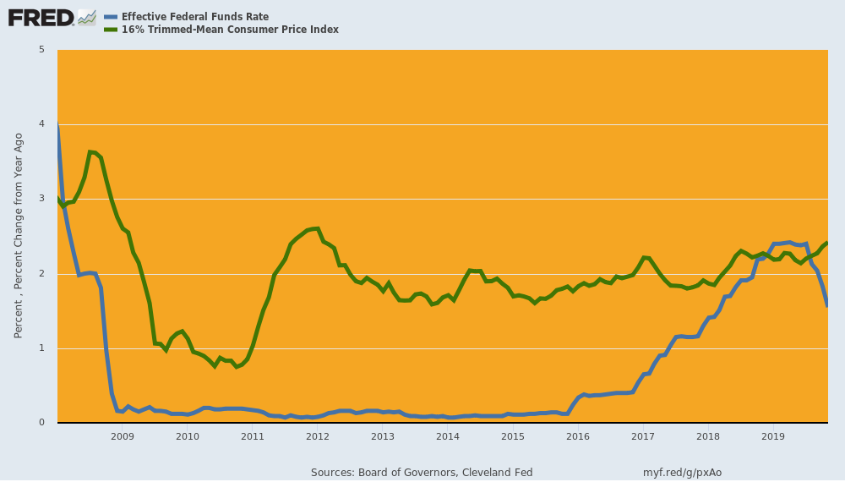
Indeed, the truly aberrant nature of the past 11 years is dramatically evident in the same chart for the decade of the 1930s, albeit with the commercial paper rate serving as the proxy for the short-term money market rate. Yet notwithstanding the virtual collapse of private borrowing during much of the Great Depression decade, nothing like the pattern since March 2008 is evident.
In fact, the money market rate (blue line) was positive in real terms during 86 months of the 125 month period (1930-1940) encompassed by the chart or 69% of the time. That's a far cry from the 5% of months in which there has been positive real carry cost since March 2008.
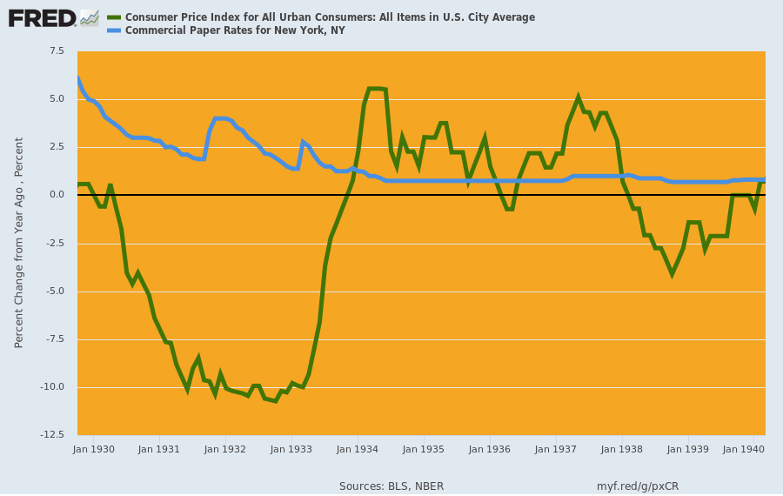
Something else is evident in the 2008-2019 central bank fostered aberration in the money market, as well. Namely, the claim that the Fed has fallen consistently behind its sacred 2.00% inflation target---thereby justifying severe and relentless financial repression---just isn't true.
The chart below covers the 29 years since 1990. The general price level as measured by the 16% trimmed-mean CPI has risen by 94% or an average of 2.3% per year. We'd not call that "low inflation" because a dollar saved by a young worker in 1990 will buy just $0.53 worth of goods and services in his retirement today.
Nor are we picking the longest measuring stick around. As indicated above, the 16% trimmed mean CPI is nothing more than a short-and-medium term smoothing device to index the underlying basket of goods and services.
Indeed, the other inflation index shown in the chart is the Fed preferred PCE deflator, and it too has risen mightily since 1990 and now stands 70% higher. That amounts to 1.9% annual inflation and $0.59 of purchasing power today for the dollar saved in 1990.
To be sure, the PCE deflator is not really an inflation index which measures the purchasing power of money over time. Instead, it's a statistical device used by the government data mills to deflate GDP and its components based on the changing composition of purchases---including the "deflation" which results during hard times when consumers substitute spam and carp for steak and lobster.
Still if you average the two indices shown below over the last three decades you get 2.1% annual inflation. That's close enough to 2.00% to call it mission accomplished---even if the mission is profoundly inequitable and counter-productive.
That is, either way savers and retirees have been shafted without any proof at all that the Fed's mindless pursuit of easier money results in more inflation and more growth.
Yet the ritual incantation doesn't stop, as evidenced by the Fed's claim it can ease to please Wall Street because inflation is below target. And that's to say nothing of the Donald's relentless refrain of the low-flation chorus, which is increasingly echoed by the GOP rank and file in Washington.
The ostensible reason, however, is about as lame as it gets. To wit, during the 21-years between 1990 and Q4 2011, the trimmed mean-CPI rose by 2.43% per annum and the PCE deflator by 2.05% per annum. Mission more than accomplished, therefore.
By contrast, since inflation-targeting was officially adopted by the Fed in January 2012, the 16% trimmed mean CPI has continued to post at 1.94% per annum or about as close as you please to target, while the PCE deflator has weakened to 1.38% per annum.
But the latter is not because suddenly American capitalism caught some mysterious low-flatation disease.
It's because the PCE deflator substantially underprices medical inflation, and has been further pulled-down by commodity and industrial goods deflation owing to a massive global supply overhang originating in the Red Ponzi and its supply chain.
It goes without saying, of course, that the latter is actually a beneficent condition for American consumers that the Fed should not attempt to correct and can't anyway.
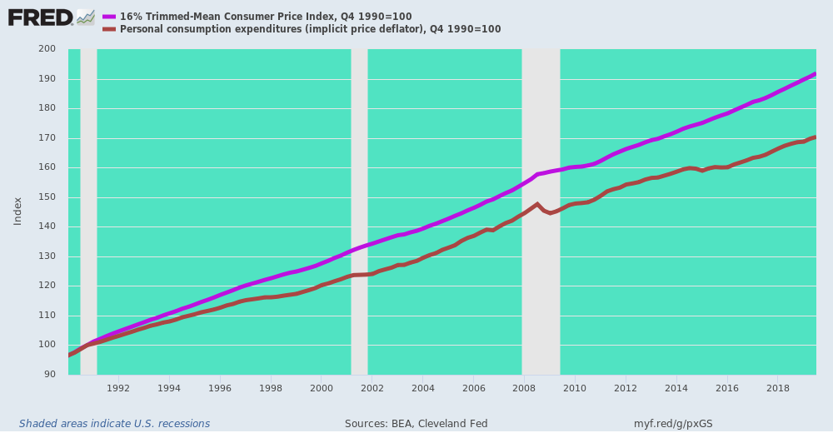
Even when a corporal's guard of Republicans on the Congressional Finance committees have occasionally scowled sideways at the Fed's doings it has been completely in the wrong direction. That is, a critique not on behalf of free market price discovery in the financial system, but in advocacy of a latter day version of Milton Friedman's "rules based" monetary central planning as now embodied in the idiotic formula of professor John Taylor.
Under his particular Rube Goldberg Contraption, the nation's monetary politburo---otherwise known as the FOMC---would peg the federal funds rate at the sum of---
- the natural rate of interest; plus
- half of the difference between the actual and the target inflation rate; plus
- half the difference between the actual GDP growth rate and the "potential GDP" growth rate.
Of course, the "natural rate" of interest---or "r-star" in central banker jargon---is just a made-up theoretical number that the Keynesian eggheads have variously estimated between 6.00% and 1.25% over the last several decades, depending up whose ox was being gored, and when.
Here's the estimates of three PhD teams at work, mainly characterized by the fact that they are all lifers at the various regional Federal Reserve banks. The latter are the only places that would actually pay a salary for what amounts to estimating the number of monetary angels that can sit on the head of a Fed funds pin.
But if you ever wanted an example of high flautin' goal-seeked analysis, the chart below is it. As the Fed has become more and more dominated by the boot heel of Wall Street speculators and has found endless occasions and excuses to shove the trend level of interest rates net of inflation (see below) steadily lower, mirabile dictu (wonder to relate), these academic scribbles have discovered equations which say the constant (r-star) is constantly shrinking!
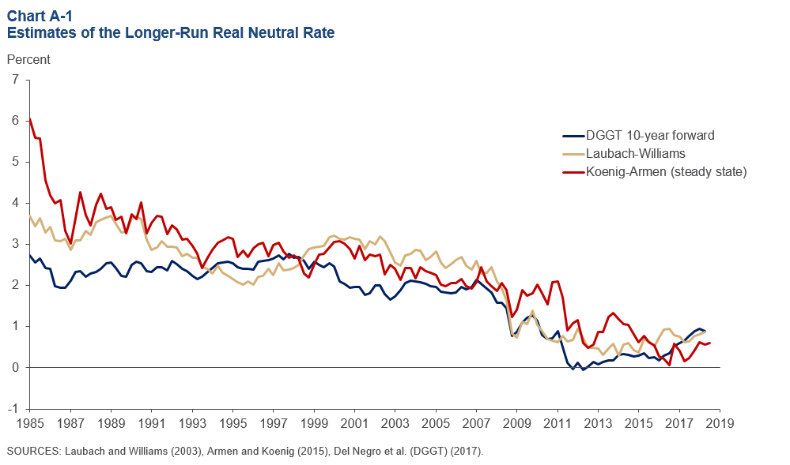
Likewise, the "inflation target rate" is another made up number, which is claimed to be 2.00% with no real empirical proof for it and much theoretical reasoning against---while the actual inflation rate can be measured six ways to Sunday based on the government's wide range of highly arbitrary and manipulated general inflation indices.
Finally, the academic phantom called Potential GDP is all in the eyes of different academic scribblers, who constantly change their minds over even short periods of time.
For instance, CBO publishes a long-term path of Potential GDP every year, but here are just the iterations from 2007 through 2015. For the year 2018, they range between $18.5 trillion and $21.0 trillion, and pretty much in descending order with each new iteration (i.e. they are always too high).
Folks, $2.5 trillion of difference is not close enough for government work; it's just noise, nonsense and analytic gibberish.
Thus, the output capacity or Potential GDP of the US is a product of millions of constantly changing financial, technological, competitive, demographic and entrepreneurial factors. It can't be conceptualized or measured. A thousand monkeys in a room of typewriters will come up with Shakespeare sooner.
Take a simple example such as the annual "capacity" of America's 50 auto assembly plants to produce finished vehicles. The "correct" answer could vary by as much as 2:1---depending upon whether you assume two eight hour shifts operating five days per week with UAW holidays and other contractual downtime versus four eight hour shifts operating a staggered schedule seven days per week with Chinese or Korean style operating tempos.
And that's only the beginning of the complexity. The level and sophistication of automation and robot operations would drive a wide range of maximum line speeds ( i.e. cars per hour are a function of capital and technology intensity). At the same time, an even greater range of supply chain reliability and proficiency factors and parts quality/rework rates would drive actual "up-times" and therefore realized line speeds.
The truth is, in today's world there is no way to standardize the Potential Output of a car plant, a lumber mill or a Pilates studio. The dynamism, flexibility and innovative capabilities of free markets militate against it and continuously shape-shift the very notion of quantifiable capacity.
Similarly, among the US population aged 19-70 (212.5 million persons) there are 425 billion "potential" work hours per year based on a 2000 hour standard work year, but only 255 billion employed hours according to the BLS.
So what happened to the 170 billion difference or the potential hours of employment and output now going unutilized? And how do they factor into the above stipulated Potential GDP?
In point of fact, they don't. The bean counters at the BLS assume that if they are work-at-home spouses (80 billion hours), full and part-time higher education students (30 billion hours) or part-time workers, social security disability recipients, pre-70 retirees, welfare bums or students living in mom's basement (60 billion hours) they don't count.
But who says? Would not different welfare policies, tax rules, student loan schemes or market wage rates (vs. unmonetized work at home) result in materially different estimates of "potential labor hours"? And wouldn't those estimates evolve and morph as the underlying government policies and private mores changed?
The point is, no one has the foggiest idea what domestic Potential GDP actually is in a dynamic, fiercely competitive market-driven main street economy.
The PhDs at the Fed and their fan-boys on Wall Street and in academia just make up this rubbish to justify what they actually do: Namely, systematically, relentlessly and destructively falsify financial asset prices, thereby flooding the system with error signals and inducements for waste and misallocation of scarce economic resources.
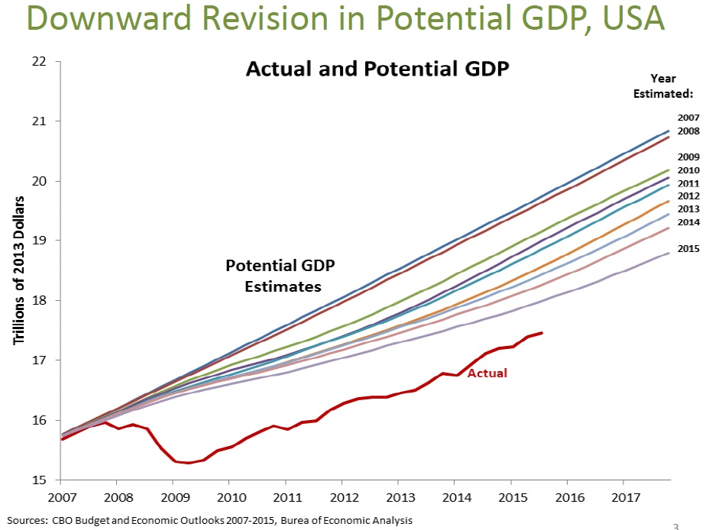
Needless to say, the GOP-favored Taylor Rule is about as close to pure crack-pottery as it comes. By the professor's own lights the Fed funds target should have been +7.5% at the top of the pre-crisis cycle in 2007 based on his 1999 estimates (red line) rather than +5.75% under his original 1993 estimates.
At the same time, it should have been -7.5% (yes, negative) per his 1999 estimate at the bottom of the Great Recession in 2009-2010 versus about -4.0% (green line) based on his 1993 estimates.
Regardless, scratch a PhD macro-economist on the Fed's ample research payroll and you will get still other iterations, such as the (green line) estimates shown in the chart below for professor Rudebusch, among numerous others.
Of course, the chart condemns itself. Can anyone in their right mind believe that it would have been anything short of flat-ass insane to confiscate 7.5% annually of the life savings of retirees just because there was a recession underway in 2009-2010?
Indeed, note the red line and weep. Professor Taylor apparently thinks that the indicated path of Fed funds would have been just ducky; and worse still, he is the economist hero of the small band of conservative Republicans, such as Senator Ted Cruz, who have even dared to suggest something is awry at the Eccles Building.
Indeed, the Taylor Rule is so knee-slapping ludicrous that these fools have inadvertently made a case for the current practice of the Bernankes, Yellens and Powells--- based on sticking their finger in the air to find out which way the Wall Street winds are blowing.
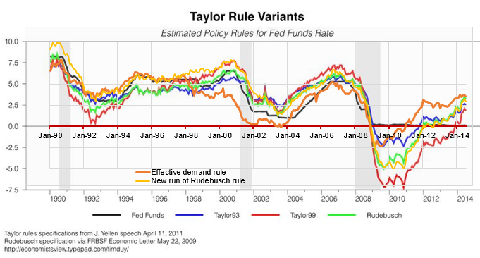
Among other things, this absolute and complete abdication of sound money by the GOP has paved the way for the impending fiscal calamity which is now baked into the cake. That's owing to a current structural deficit of 5% of GDP, the certainty of a debt and interest payment ballooning recession in the next few years and the tsunami of Baby Boom retirees which will hit the Welfare State rolls at the incredible rate of 11,000 per day beginning in the early 2020s.
What this quantifies to is $20 trillion of cumulative deficits over the next decade or a public debt which will exceed $43 trillion and 140% of GDP by the end of the 2020s, and from there it goes flat-out tilt.
That's because America's Madisonian contraption of structurally stalemated checks and balances---riven with the shrill latter day partisanship of modern times and the Trump Era especially---absolutely cannot and will not assemble the governing majorities that would be needed to slash entitlements, Warfare State spending and/or raise taxes by the truly massive amounts that would be needed to arrest the self-fueling break-out of the Debtmageddon now gathering irreversible momentum.
Yet even as late of 1990 when George Bush the Elder moved his lips in violation of his campaign promise of "no new taxes " in order to facilitate a bipartisan deficit reduction package, and when Bill Clinton did the same thing a few years later, the Congress was still populated with enough fiscal hawks and statesman---especially in the senior ranks of the GOP Senate---to keep the inherent borrow and spend proclivities of modern politicians reasonably in check.
So the question recurs: What has happened in the interim to prompt the overwhelming bipartisan majority within the Beltway to literally bury their collective heads in the sand in the face of the today's freakish condition by all historical standards: To wit, running a $1 trillion deficit or 5% of GDP at the tippy-top of the longest business expansion in history that has recession dead-ahead written all over its forehead?
The answer is in the chart below. The Fed has snuffed out even a remote semblance of honest and rational interest rates, and has thereby euthanized American politicians in a manner that could be scarcely imagined only a few decades back.
We have witnessed 50-years of fiscal policy in Washington---much of it up close and personal----and are absolutely sure about one thing. Namely that what motived
- Ronald Reagan to sign three tax increase bills in 1982-1984 after we way overdid the 1981 tax cuts and defense spending increases, as well as
- Bush the Elder and Bill Clinton to organize bipartisan packages of fiscal pain in the early 1990s,
is
- the fear of soaring interest rates and
- the "crowding out" of private household and business borrowers.
That is to say, the anti-deficit political force of angry constituents forced to forego a new home or capital investment; and also soaring interest expense on the Federal debt that would snuff out spending for the domestic and foreign pork barrels on which US politicians thrive, and from which the vast flows of campaign lucre arise.
Needless to say, what counts in this context is the real interest rate---or spread between the nominal rate and the trend rate of inflation. As we have seen, when that spread shrinks or disappears, so does the pain factor and crowding out which goes along with it. In effect, the carry cost of debt---public and private---becomes tantamount to free.
Is there any other way to describe the chart below?
When Greenspan took the helm at the Fed shortly after July 1987, the 10-year Treasury rate was 8.66% (purple line) and the inflation rate (brown line) as measured by the 16% trimmed-mean CPI was 3.82%(year-over-year), meaning that the real rate was 484 basis points (4.84%).
By December 1996 when Greenspan gave his famous and short-lived "irrational exuberance" speech, the 10-year rate was down to 6.43% versus a 2.87% CPI rate, generating a 356 basis point real rate.
From there it was a relentless squeeze until there was no inflation-adjusted content left in the 10-year Treasury note at all, which, of course, is the benchmark for all corporate and mortgage lending, as well as the fulcrum points for the entire UST yield curve and therefore the weighted average carry cost of the Federal debt.
Accordingly, the10-year treasury note, the CPI and the real long term yield were:
- 4.92%, 2.87% and +205 basis points, respectively, by February 2001;
- 3.97%. 2.22% and +105 basis points by November 2007;
- 1.89%, 2.60% and -71 basis points by December 2011;
- 2.02%, 2.20% and -18 basis points by July 2019 after the Fed's short-lived efforts at policy "normalization"; and
- 1.69%, 2.37% and -68 basis points by November 2019 after three rate cuts and the resumption of massive buying of Treasury paper under the rolling repo facilities and the new $60 billion per month T-bill purchase program or QE 4 by any other name.
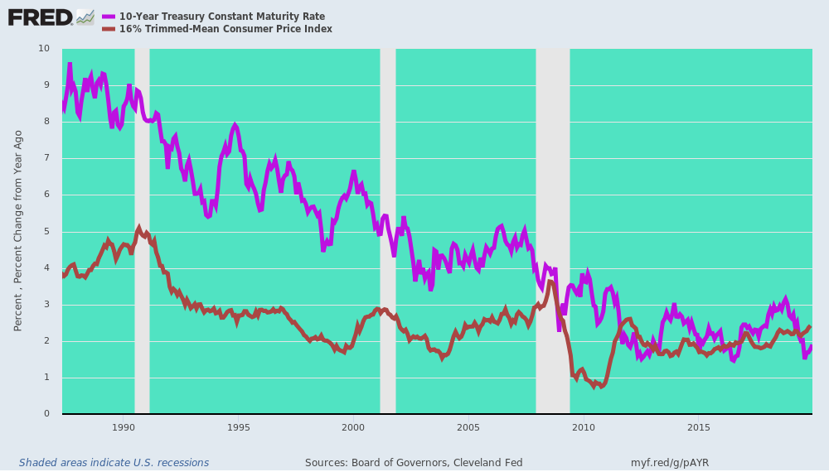
For want of doubt, negative real long-term rates are an economic toxin which destroys honest and sustainable economic calculus in the public and private sectors alike. There has never been anything like the above 30-year squeeze trend in all of economic history.
That it is paving the way for an unprecedented period of financial disorder, retrogression and losses should not be surprising; and the impending Turbulent Twenties are destined to prove exactly why.

